**Children’s Spiritual Development through Reflective Music**

**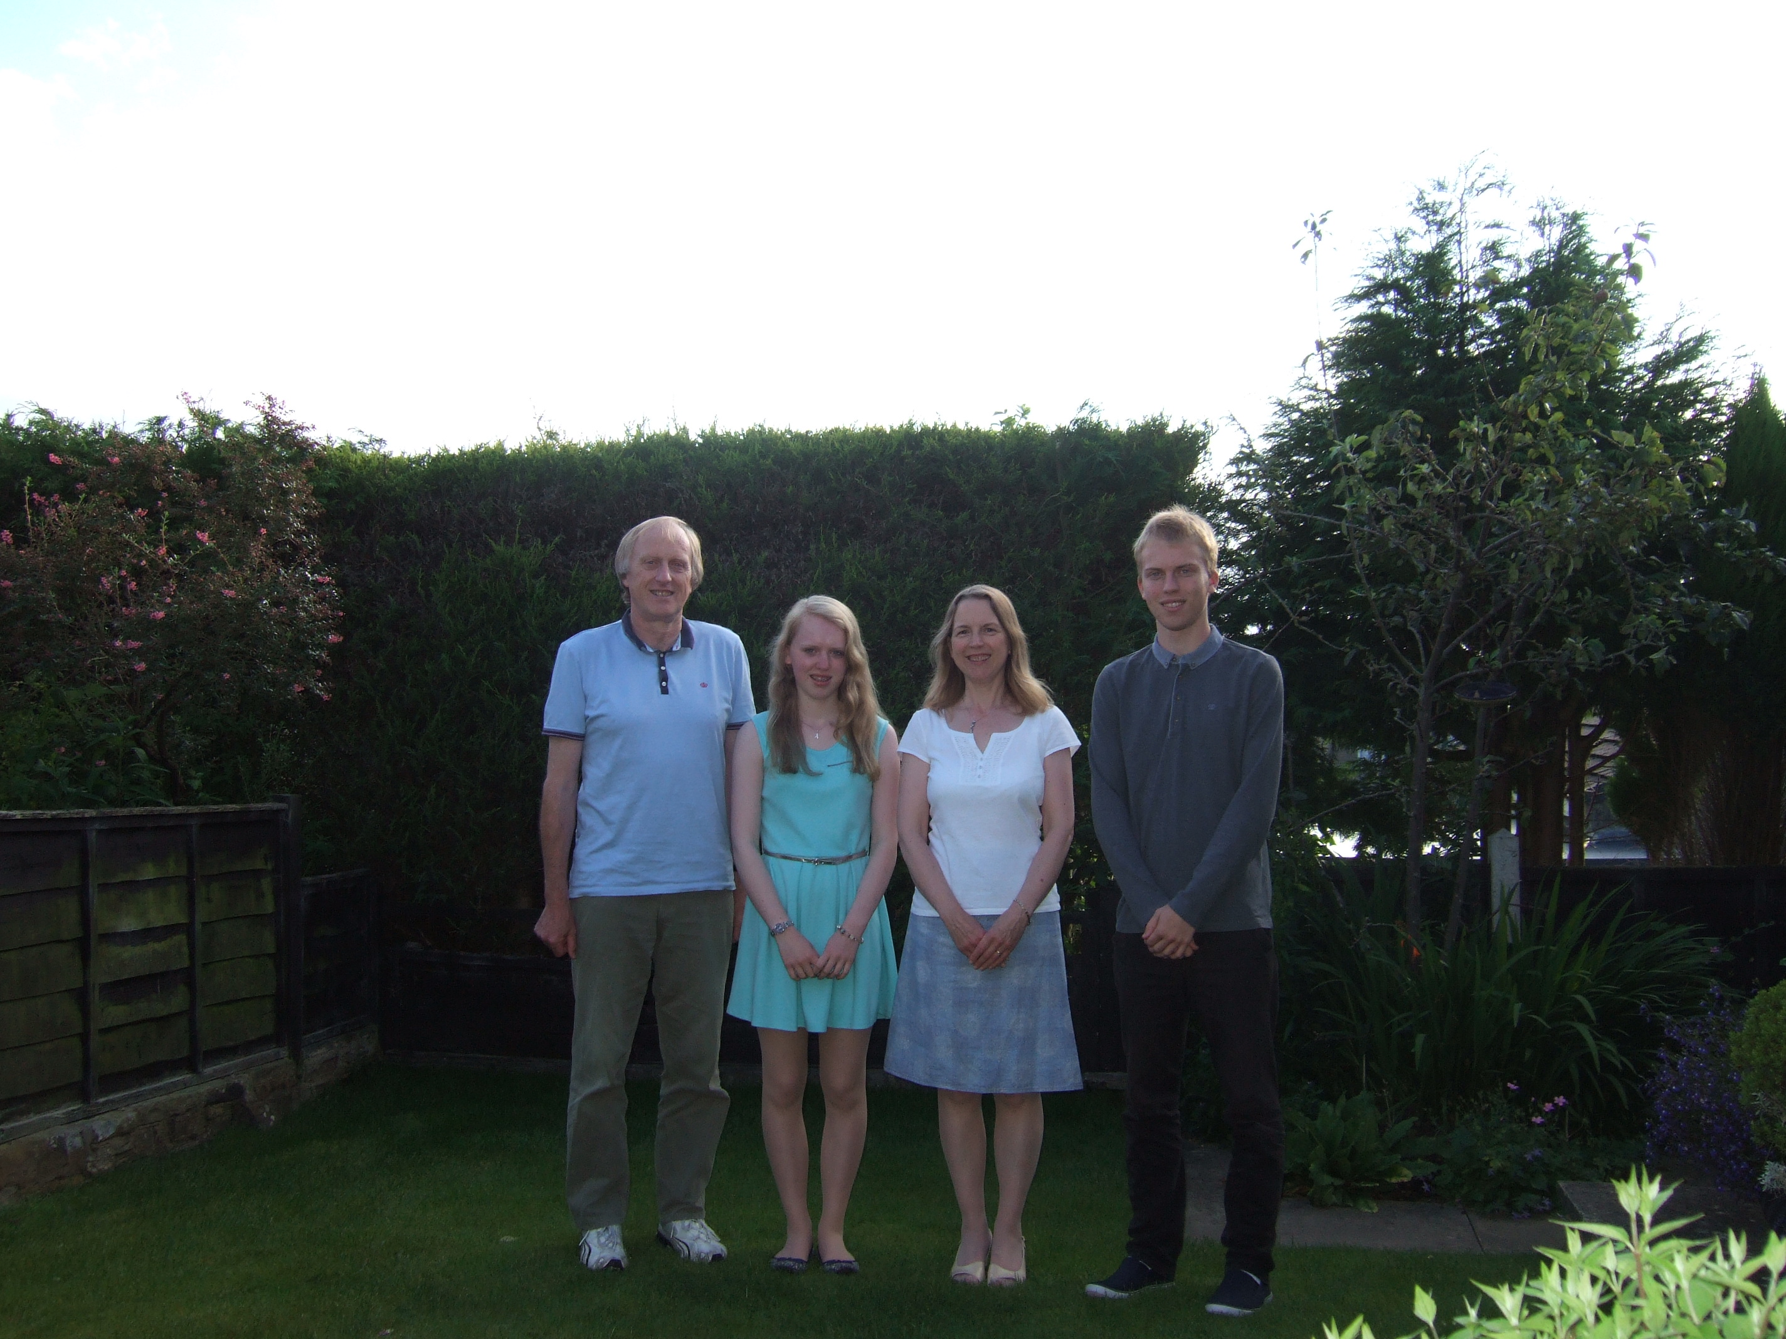*Brian Beresford*** *recently took early retirement from teaching, and was a Primary School headteacher for 20 years. An accomplished musician, Brian has taught music (orchestras, choirs, recorders, guitars as well as class music) for forty years. His main interest is in composition for children and he has published many collections of music for schools. Brian has composed and produced CDs of reflective music for school worship/assemblies entitled ‘Wanderweg’, ‘Over The Stile’ and ‘Time for Me’.*

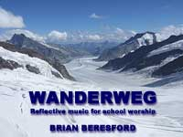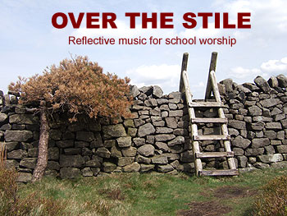

*Here Brian explains his views on the importance of music in helping children to reflect and to develop spiritually in the context of worship.*

The special ability to reflect on the awareness of one’s self and others, on life’s experiences and on the greatness of our creator is unique to the human race. People of all ages are able to reflect through varying degrees of time and depth, and yet educationalists seldom consider giving time or priority towards developing this essential aspect of what makes an individual unique. Acts of worship in schools have enormous potential for teachers to plan for reflection, and many are skilled at “stilling” children in this context, providing a calm, safe moment for children to think deeply about themselves, God, Jesus, the world, family, friends or whatever else might be part of their own awareness at that time.

The use of reflection is important in developing the imaginative part of the brain, and this helps to stimulate creativity and problem-solving. Reflection is not simply a passive act then, but something that can lead to positive benefits for each individual, group, class and school during each day. Periods of stillness are important in creating a child-centred environment, and the use of music can help to enhance an individual and collective calmness that provides each child with some mental space that can become reflective, creative and beautifully productive.

The context of collective worship is unique in providing an opportunity for collective reflection, and I feel privileged to be able to witness every child in my school become consciously involved in the reflective act.

Choosing appropriate music for reflection is a challenge in itself. Teachers leading worship frequently pick a piece of quiet classical or guitar music, put on the first minute of a track and try to encourage the children to think deeply while it is playing. This can be successful, but it can also become very tedious for children who may associate a few moments sitting on a hard floor with having to listen to “that Hovis bread tune again”.

As headteacher and worship co-ordinator, I often struggled to find a piece of music that gives me what I need, i.e. an atmospheric piece to enhance the potential for reflection in worship. I believe that reflection is very important in this context, for it can encourage children to concentrate deeply and look into their own experiences and the world around them, even giving them an opportunity to discover their own spirit and meet with God. Providing such opportunities is something to be taken very seriously, and it was the difficulty faced by teachers searching for appropriate music that led me to compose and produce a CD to meet that need.

Writing pieces for reflection during worship was something that I did in the evenings over several months, working on my PC with keyboard and recording studio. I found that if I could feel myself taking on a reflective sensation I could create more appropriately for the purpose in hand. Thus, some of the results have an instant, instinctive feel because of their creation during my own reflective moments in time. The first CD is entitled *Wanderweg* - my family had visited the spectacular Bernese Oberland in Switzerland, walking Alpine paths among such giants as Eiger and Jungfrau. In this German-speaking part of Switzerland, the paths are signed “Wanderweg”, meaning “hiking path”. I decided to use that word as the title of my CD because it is my aim that the music can help take children’s spiritual development and worship to a higher level.

The ‘Wanderweg’ CD was published and made available through [www.onemoretime.biz](http://www.onemoretime.biz). It soon became a “best seller”, and is now used in 1,000 schools. I produced a second CD of 24 tracks entitled ‘Over The Stile’ and then ‘Time for Me’, a further collection for Early Years and Key Stage 1 children

The approach I have taken is fully inclusive as, of course, the ability to reflect has nothing to do with affiliation to any particular faith, and the way a child responds to the music is as an individual, rather than as a Christian, Jew or any other faith background. Similarly, children from families with no faith background are equally able to respond.

In my schools, appropriate music was played while children were guided through meditative stillness in the presence of a lit candle. Suitable images/photographs were sometimes projected onto a screen, but the children became accustomed to closing their eyes, becoming aware of their own slower breathing and allowing their thoughts to develop within their own spiritual space. All the children could reflect together in this way. The quality of such reflective experiences cannot be quantified, but the benefits for personal development are huge.

WANDERWEG, OVER THE STILE and TIME FOR ME as available from [www.onemoretime.biz](http://www.onemoretime.biz), price £10 each (+ VAT) The website includes snippets of many of the tracks.